Pengajuan Dana

1. Samsat FJ Cruiser hitam 2014 B 307 CHA

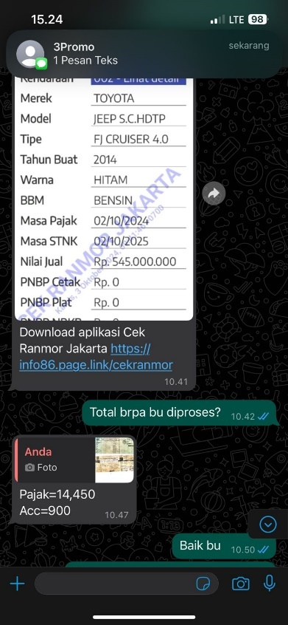

1. Samsat BMW Z4 BIRU BM 4 Z

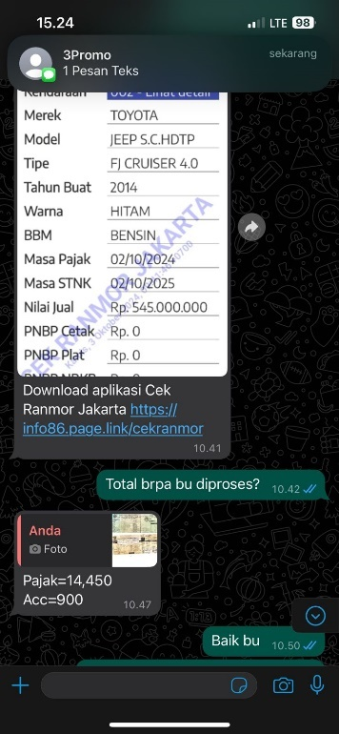

1. Samsat CRV PUTIH 2019 DK 1418

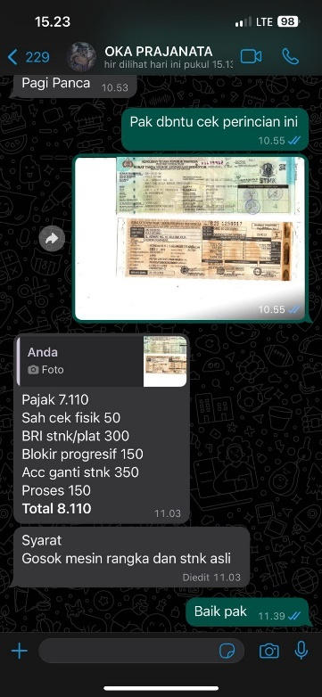

1. Cat Rubicon Short B 1780 BJT

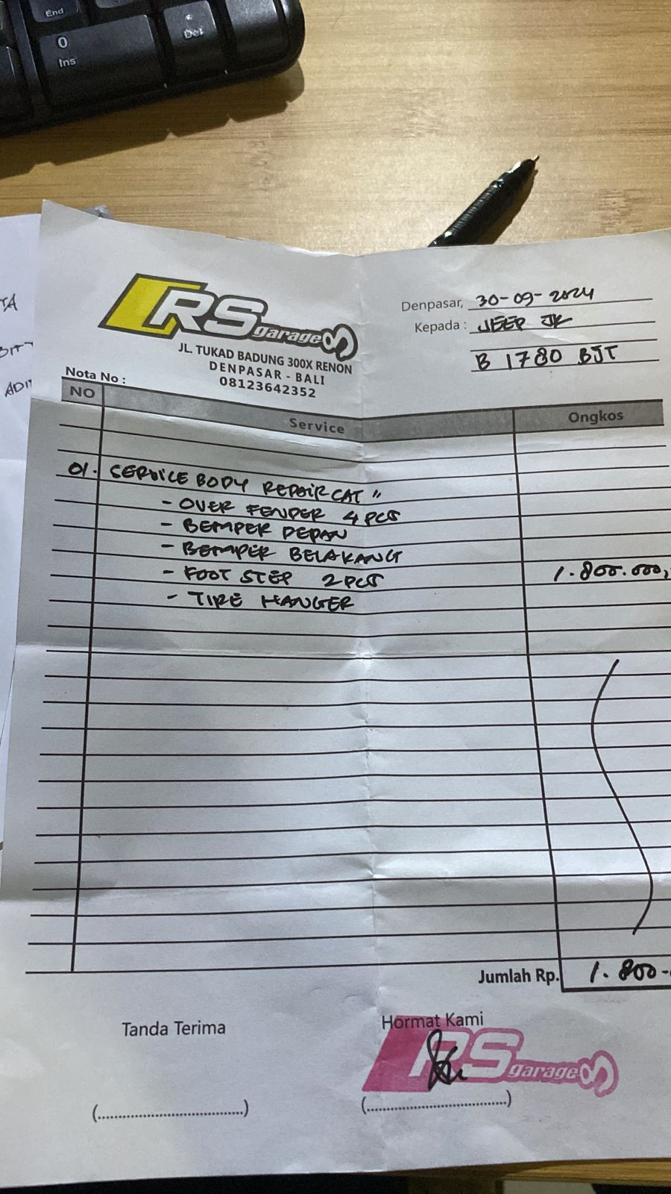

1. Cek Mercy GLS

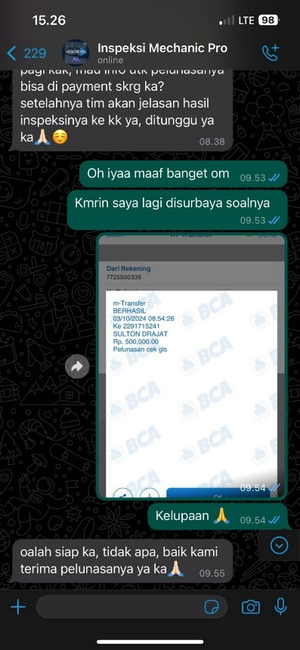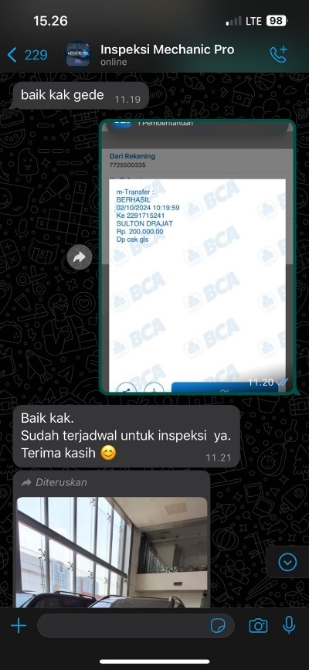

1. Cat 4velg Mercy C300 2019 DK 1084 ACZ
2. Lampu LED Jeep JK B 1780 BJT

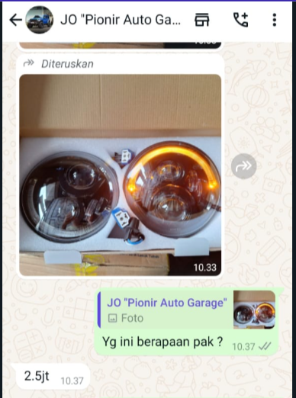

1. Service BMW X5 D 1420 HA

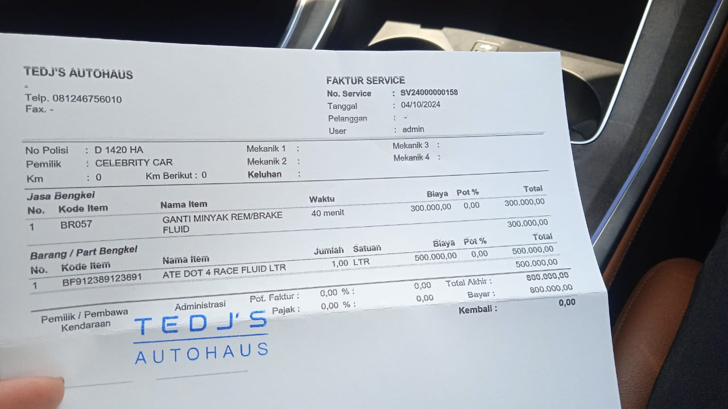

1. BAN MERCY GLC HITAM DD 1908 FL

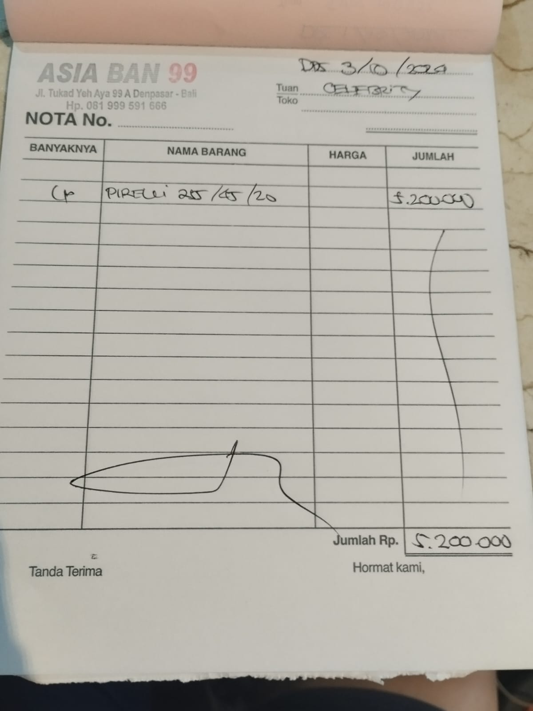

1. CAT VELLFIRE 2015 B 2389 SFT

